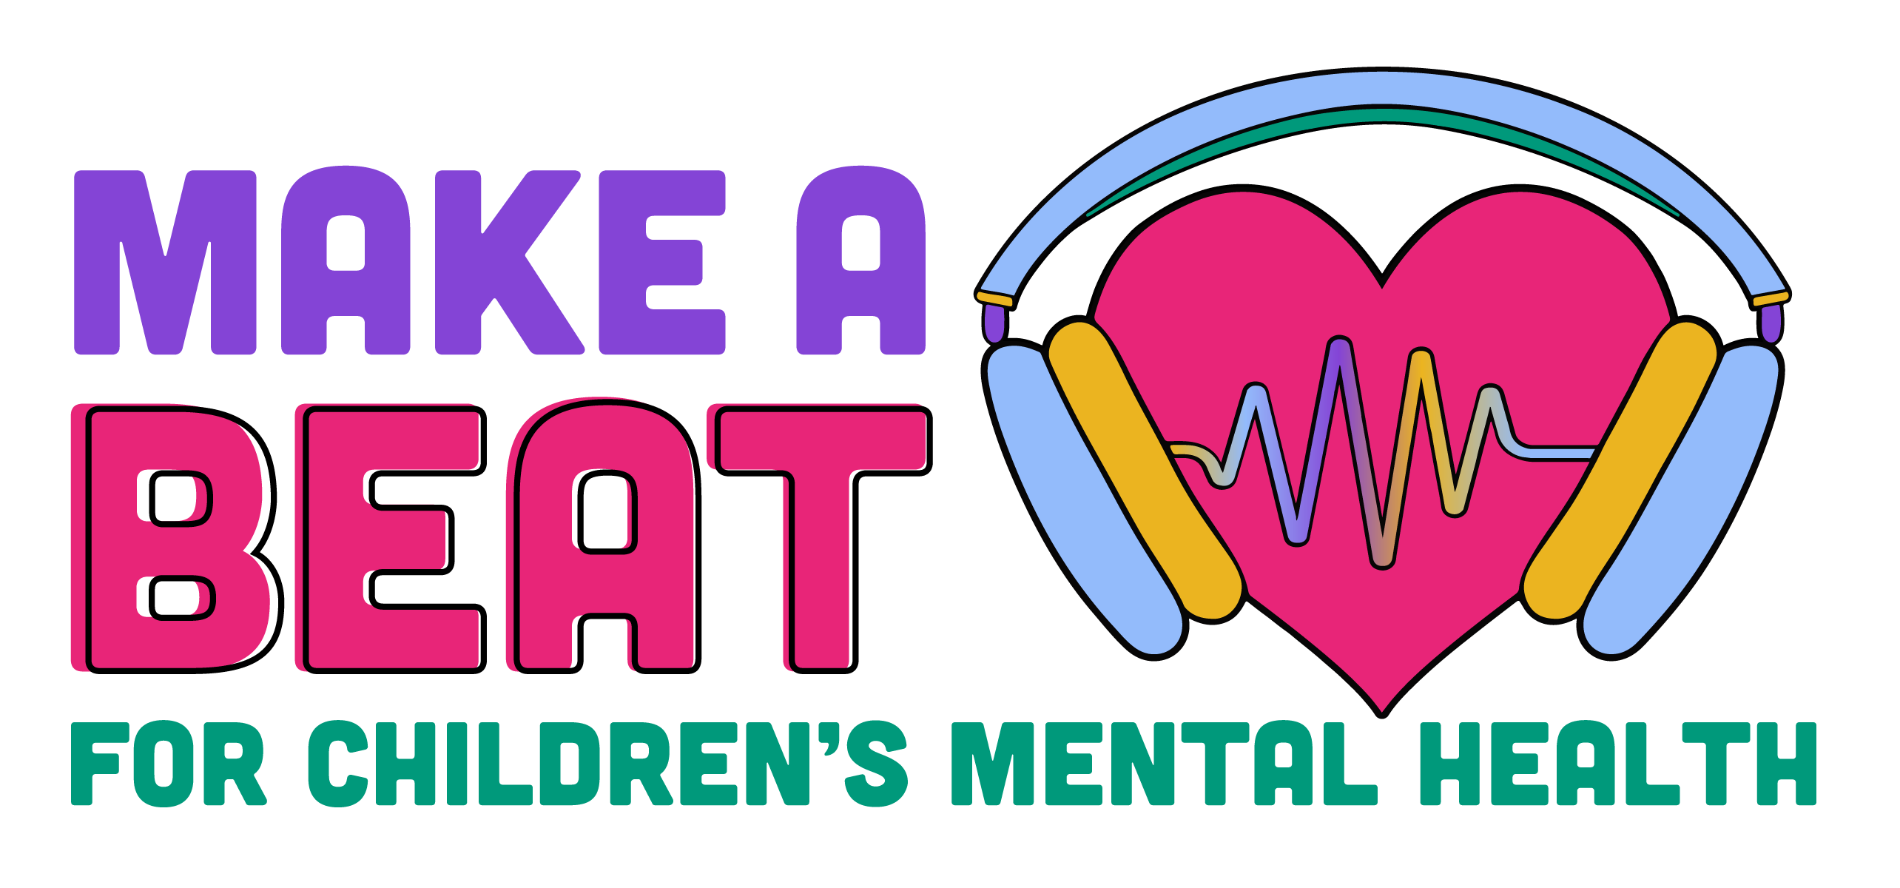

DRAFT PROCLAMATION

RESOLUTION
Children’s Mental Health Acceptance Day

WHEREAS, good mental health is a key component in a child’s healthy development and Children’s Mental Acceptance Day provides the opportunity to focus on this important matter while celebrating the accomplishments of children and families affected by mental health concerns; and

WHEREAS, one in five children is diagnosed with a mental health condition, according to the United States Department of Health and Human Services; and

WHEREAS, research has shown early identification and appropriate treatment of mental health disorders among children and adolescents provide them with better opportunities to lead full and productive lives; and

WHEREAS, children and youth with mental health problems and their families benefit from access to timely services and supports that are family-drive, youth-guided, and culturally appropriate; they also benefit from the integration of behavioral health in primary care, education, and child welfare; and

WHEREAS, it is important that children and adolescents, along with their families and communities, learn about warning signs of mental health disorders and where to obtain necessary assistance and treatment; and

WHEREAS, obtaining a full and accurate diagnosis of a child requires gathering information from diverse sources, including the family, school, and others involved with the child; and

WHEREAS, [organization name] is observing Children’s Mental Health Acceptance Day by holding [name of event]; and

WHEREAS, [organization name] is committed to improving the system for our children with mental health needs;

NOW THEREFORE BE IT RESOLVED that [Name] County does hereby proclaim [date of event], 2022, Children’s Mental Health Acceptance Day in [Name] County; and

BE IT FURTHER RESOLVED that [Name] County supports the [name of event] and all other work of [organization name]; and

BE IT FURTHER RESOLVED that [Name] County joins with counties across Texas to support Children’s Mental Health Acceptance.

