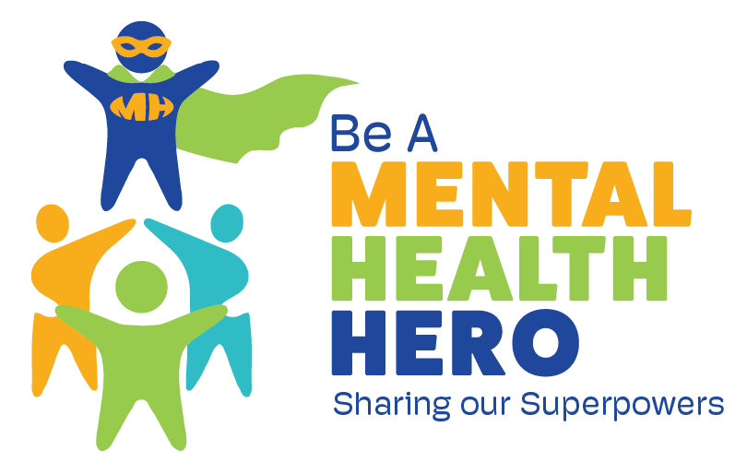

For Immediate Release
[Insert Date of Release]

For additional information or to arrange interviews, contact:
[Insert Name] | Office Phone: 000.000.0000 | Cell Phone: 000.000.0000 | [Insert Email]

[Agency or Community Name] Joins Statewide Celebration to Promote Children’s Mental Health Acceptance

On [date], [collaboration, agency or community] will join communities across Texas to recognize children’s mental health with a national and statewide theme and focus on children’s mental health acceptance.

Members of [collaboration, agency or community] are hosting [insert actual name of the event], a free community event open to the public at [location]. Counties throughout the state are participating in similar events.

In December of 2021, the Surgeon General issued an advisory highlighting the urgent need to address our nation's youth mental health crisis further exposed by the COVID-19 pandemic. Never has this been more urgent, as the nation and state see an alarming rise in the incidence of mental health concerns in children.

One in five people will experience a mental illness at some point in their lives. [Agency, collaboration] says that youth in the community youth are facing serious challenges ahead that need to be addressed, and that mental health challenges must be met with understanding and support. Bias and discrimination toward individuals who experience mental health challenges creates a barrier to seeking treatment — and it must be eliminated.

[Agency, collaboration] invites the community to join the celebration at [location, including street address, city, state and zip] from [start time] to [end time]. [Include any additional information about directions to the location, parking, etc.]

[Name of event] will include [list activities, speakers, etc].

[Paragraph describing your collaboration/agency]

