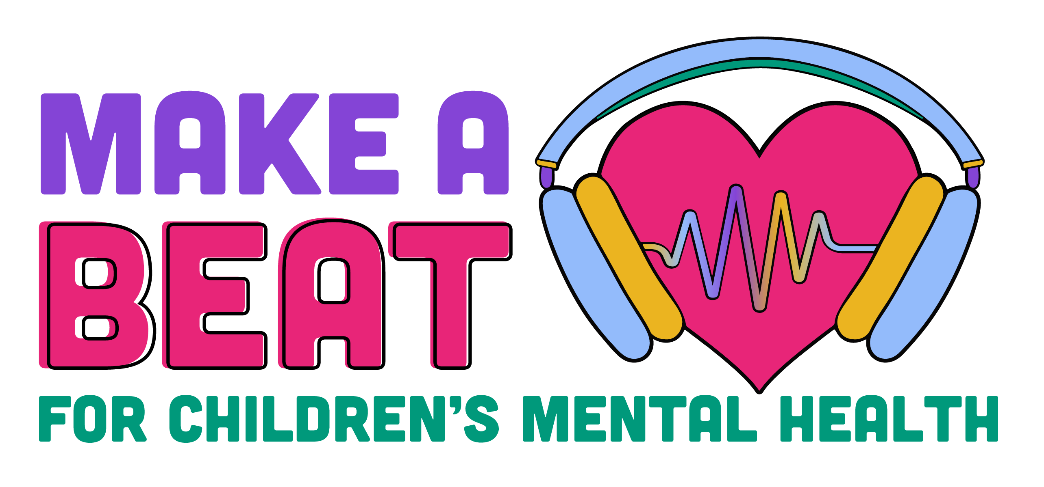

For Immediate Release
[Insert Date of Release]

For additional information or to arrange interviews, contact:
[Insert Name] | Office Phone: 000.000.0000 | Cell Phone: 000.000.0000 | [Insert Email]

MEDIA ADVISORY
[Agency or Community Name] to Celebrate Children’s Mental Health Acceptance

What: Children’s mental health advocates, ranging from children, youth, their families, providers, and other stakeholders throughout the community will join together on [date] to celebrate Children’s Mental Health Acceptance Week, joining a statewide and national campaign throughout May to address our nation's youth mental health crisis further exposed by the COVID-19 pandemic.

When: [Date]
[Time]

Where: [Name of Venue]
[Address, city, state zip]

Who: [List of speakers and/or other participants with their titles]

Why: In December of 2021, the Surgeon General issued an advisory highlighting the urgent need to address our nation's youth mental health crisis further exposed by the COVID-19 pandemic. Never has this been more urgent, as the nation and state see an alarming rise in the incidence of mental health concerns in children. One in five people will experience a mental illness at some point in their lives. Bias and discrimination toward individuals who experience mental health challenges create a barrier to seeking treatment — and it must be eliminated.

Registration: [Any registration information if needed]

Information: [Background on organization or agency leading the event]

Visuals: At approximately [time], [estimated number] of participants will gather and promote children’s mental health by [discuss event specifics here that will be of interest to local media].

